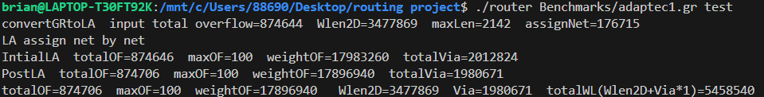
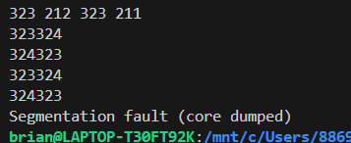
History cost
Nonlinear Cost function

